1. Open and display the image “dog.jpeg”. Convert the image in to numpy array,so that i can be used in further processing.

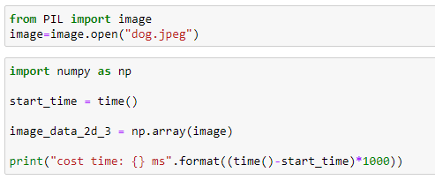

2. Find out the dimensions of the image and convert it in to a two dimensional array

